Name:

Primary School:

PHGS Form:



Year 6 Student Portfolio

“Proud of the past, prepared for the future”
LEARNING OVERVIEW

These are the Prince Henry’s Grammar School Attitude to Learning Indicators – how would you rate your Attitude to Learning in all subjects?
Attitude to Learning |  | Rate your AtL | Teacher rating | Level of AtL has been shown to be one of the best predictors of outcomes in examinations.
1 | Outstanding Attitude |  |  | You are very ambitious and your outstanding engagement with learning, in school and at home, enables you to stand out from the majority of students in your year group.  You are a self-motivated, resilient, independent learner.
2 | Better than expected Attitude |  |  | You are keen to succeed and sufficiently engaged with learning, in school and at home, to stand out from many of the students in your year group.  You are an enthusiastic, responsible learner. Increased self-motivation, resilience and independence would make you an outstanding learner.
3 | Minimum Expectation for Attitude at Prince Henry’s |  |  | You like the idea of being successful but the level of engagement with learning, in school and/or at home, rarely enables you to stand out from other students in your year group.  You are a learner who does what you are asked to do, but rarely extend yourself and are too easily satisfied with your progress. Increased enthusiasm and taking responsibility for your own learning would make you a better than expected learner.
4 | Below Expected Attitude |  |  | You need to be more ambitious in order to achieve your true potential. Your level of engagement with learning, in school and/or at home is below the level of most of the other students in your year group.  You are a learner who may need to improve listening, concentration or behaviour in class. You may need to improve your response to home learning or deadlines. Doing everything that you are asked to do would raise you to the minimum expectation for Prince Henry’s.

Explain why you selected your AtL here:

Why did your teacher select the AtL they did?

English Overview

Literacy Targets at end of y6:

My Attitude to Learning in English is:

ENGLISH SELF ASSESSMENT
Reading
Do you enjoy reading? Why?

Do you have a favourite author?
Do you read: every day, a couple of times a week, once a week, hardly ever?

What genre of books do you prefer to read?
What do you find the biggest challenge with reading?

What kind of books do you think you will be reading at PHGS?

Writing
Do you like to write at school?
Do you sometimes choose to write at home and if so, what do you like to write?

Are you a good speller?
What do you find the biggest challenge to writing?

Are you looking forward to writing at PHGS?
Speaking and listening
Are you a good listener?

Are you confident at explaining your ideas to other people?

Are you someone who offers their ideas and answers in class?

Do you enjoy the opportunity to perform?

English Overview

Fantasy Character – During your Transition lesson at Primary School, you can draw your Fantasy character and write a description of them here. Think of their age, interests, history and any special skills they might have
______________________________________________________________

______________________________________________________________

______________________________________________________________

______________________________________________________________

______________________________________________________________

______________________________________________________________

______________________________________________________________

______________________________________________________________

______________________________________________________________

______________________________________________________________

______________________________________________________________

______________________________________________________________

______________________________________________________________

______________________________________________________________

English Overview

______________________________________________________________

______________________________________________________________

______________________________________________________________

______________________________________________________________

______________________________________________________________

______________________________________________________________

______________________________________________________________

______________________________________________________________

______________________________________________________________

______________________________________________________________

______________________________________________________________

______________________________________________________________

______________________________________________________________

______________________________________________________________

______________________________________________________________

______________________________________________________________

______________________________________________________________

______________________________________________________________

______________________________________________________________

______________________________________________________________

______________________________________________________________

______________________________________________________________

Maths Overview

Challenge: Find out everything you can about “Fibonacci Numbers” and “Fibonacci Sequences” using the internet and/or library. Design a poster below about what you have found out.
You should include:
1. What are Fibonacci numbers?
2. What is a Fibonacci sequence?
3. How can you work them out?
4. Where do you find Fibonacci numbers in nature?

Maths Overview

Numeracy Target at end of y6:

Self-assessment:

My strengths are:

My areas to improve are:

My Attitude to Learning in Maths is:

Science Overview

Tell us about your favourite Science work in KS2

Science Overview

The topics we have covered in Year 6 are:

Self-assessment:

My strengths are:

My areas to improve are:

My Attitude to Learning in Science is:

Languages Overview

The language I have studied at Primary School is:

When studying languages, I have really enjoyed…

The area I need to improve most is…

My Attitude To Learning is:

Show us an example of your best work… tell your languages teacher something about you…

Geography Overview

The Geography topics I have studied at Primary School are:

When studying Geography, I have really enjoyed…

When I start at Prince Henry’s, the Geography topics I would most like to learn about are…

Show us an example of your best work… Create a poster/mind map all about your favourite place/country/Geography topic:

History Overview

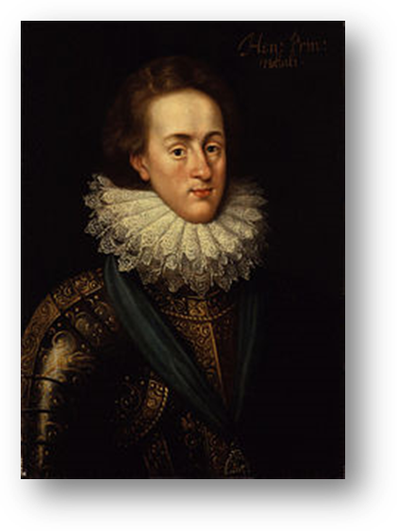
Who was Prince Henry?

Our school was set up in 1607 after King James I dedicated a school to his eldest son, Henry Frederick, Prince of Wales.

Prince Henry was born in 1594. He was the grandson of Mary Queen of Scots and the son of King James – the very same King that the Catholic plotter Guy Fawkes planned to blow up in the gunpowder plot of 1605. He was a talented sportsman and loved art, collecting lots of art work. He was well known for being strongly against the Catholic religion. He died in 1612, only 5 years after our school was set up. 2000 people came to mourn at his funeral.

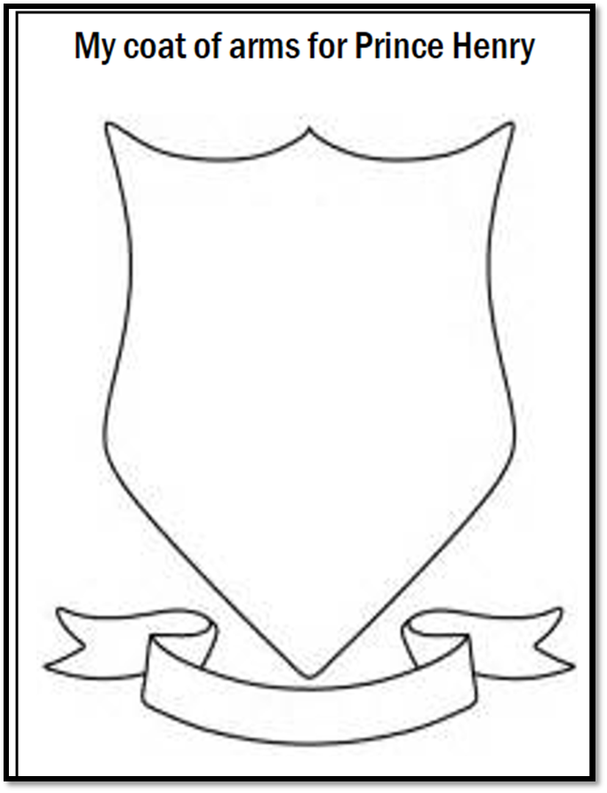
TASK: Read the description of Prince Henry & then add images to a coat of arms to represent his character. Explain your choices below:

My coat of arms includes:

I chose this because:

THE YEAR 7 CHALLENGE!
Independent Research

This challenge has been put together by the Year 7 School Council team at Prince Henry’s.
They have come up with a series of questions that you will be able to find the answer to either using the school website (www.princehenrys.co.uk) or asking family and friends who are already at Prince Henry’s.
They are certain the answers to these questions will give you a head-start in your time at Prince Henry’s.
Good luck!

- What is the name of the Headteacher at Prince Henry’s?

- How many students go to Prince Henry’s?

- What time does the school day start?

- How many lessons are there in the school day?

- How long is each lesson?

- How long do you have for lunch?

THE YEAR 7 CHALLENGE!
Independent Research

Remember you will be able to find the answer to questions using the school website (www.princehenrys.co.uk) or asking family and friends who are already at Prince Henry’s.

- What is the post code and phone number at Prince Henry’s?

- What year did the school open?

- What is the school motto?

- Can you find two school uniform rules that will apply to you?

Do you still have some questions?
Record them here…

