Task 1 - What will be the output for each of these pieces of pseudocode?

Output:

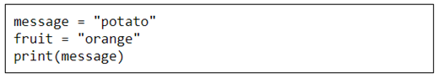

Output:

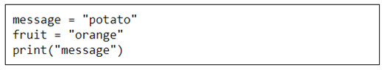

Output:

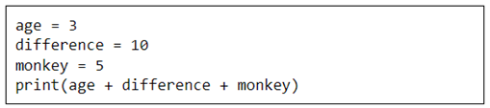

Output:

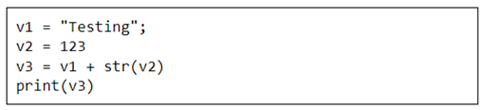

Output:

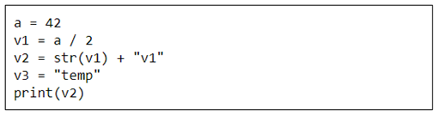

Output:

Task 2 - What ranking would each player get?

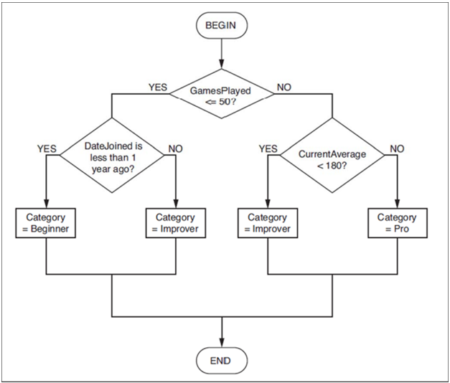

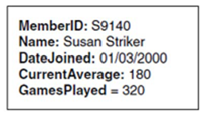

Ranking:

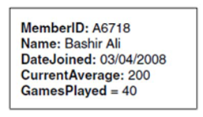

Ranking:

Task 3: Which subject should each student take?

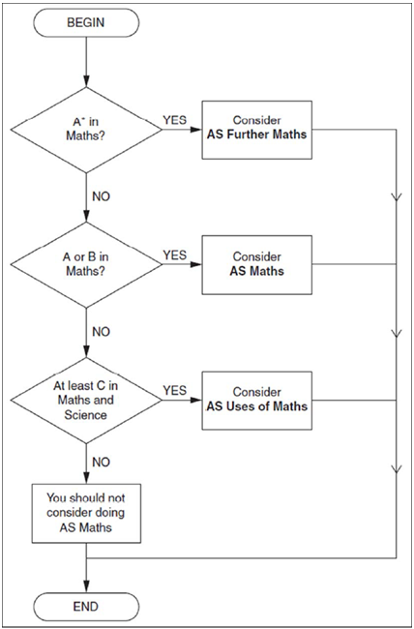

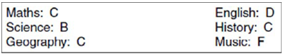

Subject:

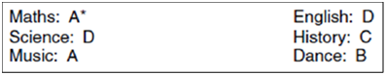

Subject:

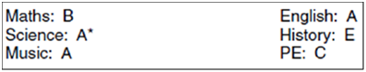

Subject:

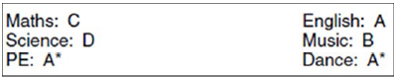

Subject:

Task 4 - What would be the output of each of these selection (IF) statements?

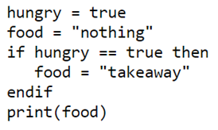

Output:

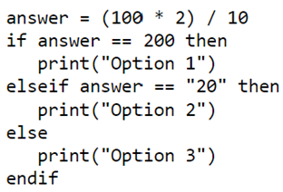

Output:

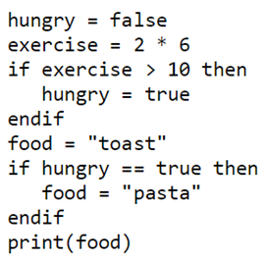

Output:

Task 5 - Pseudocode Challenges

- Ask the user to enter their score in a suitably named variable
- If a student gets 85% or more on a test it should output “Distinction”
- If a student gets between 65% and 84% (inclusive) it will be a “Merit”
- If the student gets between 40% and 64% (inclusive) it will be a “Pass”
- Anything less than 40% will be a “Fail”
- Output the grade

score = input(“Please enter your score”)
if score >= 85 then
print(“Distinction”)
else if score >= OR score <= then
print(“Merit”)
else if score >= OR score <= then
print(“ ”)
else if score < 40 then
print(“ “)
end if

-----------------------------------------------------------------------------

- Store the test grade of a C in a suitably named variable
- If the student got an A or a B grade then it should output “Well Done”
- If the student gets a C grade it should output “Room for Improvement”
- If the student got any other mark then it should say “Try Harder”
- Output the feedback

grade = input(“ ”)
if grade == “A” OR grade ==”B” then
print(“Well Done”)
else if then
print( )
else
print( )
end if

- Ask the user to enter a whole number called value A
- Ask the user to enter a whole number called value B
- If A is less than B then it should output “A is less than B”
- If A is more than B it should output “A is more than B”
- If A and B are the same then it should tell them

valueA =
valueB = input(“ “)

if A < B

else if

else if

end
-----------------------------------------------------------------------------

- Ask the user to enter the tier choice
- Ask the user to enter the persons age who the ticket is for
- If they are booking in the lower tier then:
  - seats for over 65’s will be £10
  - below 16 are £5.
  - All others lower tier seats are priced at £20.
- For the upper tier, all tickets are increased by £5 from lower tier price.

tier = input(“ ”)
age =
if age > then
ticket = 10
else if age < then
ticket =
else
ticket =
end if
if then
ticket = ticket +
end if
print(
Ask the user is they are booking in a dog or a cat. Also, ask them how many days they want to book the pet in.

The standard cost is £20 per day.

If the user is entering a cat then it should ask them which package they want (Gold or Silver)

If they entered the gold package then it should multiply the cost and days then add a 25% extra charge. Otherwise, the silver is just the cost multiplied by days.

If the user is entering a dog then it should ask them which package they want (Platinum or Gold)

If they entered the platinum package then it should multiply the cost and days then add a 25% extra charge. Otherwise the gold it is just the cost multiplied by days.

pet =
days =
dayCost = 20
cost = days * dayCost

if pet == “ “ then
package = input(
if package == “gold” then
cost = cost * 1.25
end if
else if pet ==
package = input(
if package == “ ” then
cost =
end if
end if
print (“Your “ + package + “ will cost” + )

- Ask the user how many people are travelling together.
- Ask the user how long their journey is in miles. The standard charge is £6 per mile
- If there are 4 or more travellers and their journey is more than 5 miles then it should apply a 10% discount
- If there are 2 or 3 travellers and their journey is more than 5 miles then it should apply a 5% discount
- Every other journey is the standard price

travellers =

