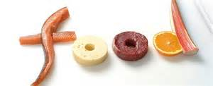
Food Science and Nutrition

Is this course right for me?
If you are thinking of opting for this subject it may be worth asking yourself the following questions:
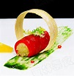
• Do you want to develop further your knowledge of food science, nutrition and health and safety within the food industry?
• Do you enjoy cooking?
• Can you rely on yourself to remember to bring in your ingredients?
• Are you interested in the impact food has on everyday life?
• Do you want to improve your designing and making skills using food?

Before the course starts you need to carry out the research and tasks below.

Nutrition is a key part of the course and you will need to have a clear understanding of nutrients and healthy eating.
Watch the video link to learn more about what is meant by a healthy diet. Explain what a healthy diet is and the key elements of the Eatwell Guide.
https://www.youtube.com/watch?v=1tJYcNt6Bpk
Explore the concept of energy intake, expenditure and energy balance. https://www.youtube.com/watch?v=d-5w67NAOlo
Task: Watch the podcast about energy and answer the questions below.
What is energy?
Why do we need to eat food?
How much energy do we need?
What are the factors that affect 'energy out'?
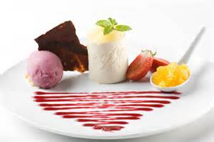
What is energy balance?

Food Presentation: It is important to understand how to layout food products in order to improve tier visual appearance. Use the following websites and videos to investigate what makes food look good. You are welcome to search for other tips and guidance on food presentation techniques. This is partially important, as you will be required to photograph the products you make.
Task: Write a list of tips and ideas for successful food presentation.
http://www.howtocookgourmet.com/foodpresentationtips.html
http://www.cravemag.com/features/the-art-of-food-presentation/
https://www.youtube.com/watch?v=Udzs_MPNpMQ
https://www.youtube.com/watch?v=9YBnczqciHI

Food in the news: Create a “food in the news” media folder. Between now and the beginning of September collect any articles that you find referring to Food and Nutrition.

The Guardian and Observer newspapers, the BBC news and the BBC Good Food Magazine are good starting places. You could also look at the free papers and magazines available at food retailers.
Task: Select 2 articles that you think are important/news worthy. Summarise the key points and explain why you think that each article was published/written.



