Dominant, Minor and Major 7ths. How to spot them AND how to use them!
Dominant 7th = Major triad with flattened 7th (i.e. two semitones down from the tonic). VERY common with chord V. Has an ENORMOUS magnetism towards the chord a 4th above (e.g. I, if used as V7).
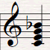
Minor 7th = Minor triad with flattened 7th (or flat 3, flat 7). This is what you get if you add a 7th to chords ii, ii or vi in a major key. Can be very effective.
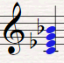
Major 7th = Major triad with a major 7th (i.e. one semitone down from the tonic). This is what you get if you add a 7th to chords I and IV in a major key. Sounds bright/dreamy/wistful!
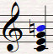
Task – example.
Let’s take a very straightforward pattern and add 7ths
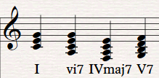Sounds different but (crucial bit) it’s not very musical for two reasons

- Voicing. Pianists just don’t write like this! It sounds bad. Neither do orchestrators. Here are the same chords but revoiced:
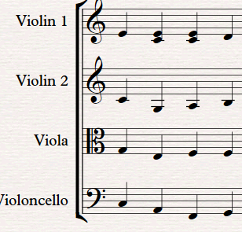
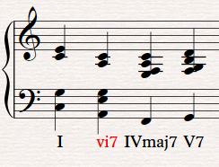

And here they are revoiced BUT with the notes spread amongst a string section

Finally – Groove! Here they are, revoiced BUT with a bit of rhythmic identity


