Functional harmony 2
This is what an inversion looks like in it’s simplest form:
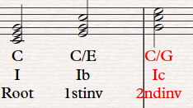
Remember ONLY the lowest note affects the inversion so the one below is a root position chord despite the right hand pattern:
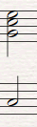
1st inversions like to resolve by step in the bass. Really common progressions are:
Ib-IV (illustrated below)
Vb-I
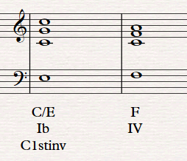

BUT.. they don’t have to do this! IVb-I, for example is a lovely progression, as are other progressions where the bass line moves by a 3rd.
ALL of the above progressions can easily be reversed

1st inversions are really useful for:
- Creating flowing bass lines
- Avoiding having the same chord twice (see below)
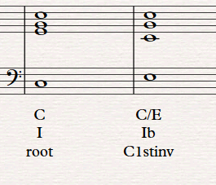
Second inversions are special. They are also called a 6 4 chords. They can ONLY be used in two ways (mainly only the first one). This is also a favourite chord of examiners so learn how it sounds!
The cadential 6/4 progression:
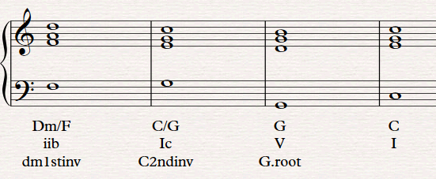
Notice how the bass note doesn’t change, although it often jumps down an octave
The passing 6 4 chord is a little harder to understand. Basically, it is a 2nd inversion chord where that is approached AND resolved by step in the bass:
A Passing 6/4 progression:


