Home School Agreement
These rules will keep you safe and help us be fair to all our students:

- I will keep my pass code secret
- I will not access another person’s iPad or storage area, or interfere with other people's work or files
- While at school, I will only use my iPad for school work and home-learning
- I will store my iPad in my bag when not in use
- I will not behave in a way that could result in damage to any iPad
- I will not give my home address or telephone number, or arrange to meet someone, unless my parent, carer or teacher has given permission
- I will report any unpleasant material or messages sent to me. I understand this report would be confidential and would help protect other students and myself
- I understand that the school may check my files and may monitor the Internet sites I visit in school
- I will not install any apps that breach age restrictions

Terms and conditions
- Failure to take reasonable care of the iPad or to abide by the other conditions listed in this document may result in the iPad being reclaimed or school sanctions being applied.
- The school also reserves the right to claim financial recompense in such cases.
- If the iPad is used to connect with the Internet from home, the school will not be responsible for any cost involved.
- The iPad should be fully charged at the start of each school day
- Please take the time to read the full acceptable use agreement on the school website. This is also available in paper form by request.
Address:
Prince Henry’s Grammar School
Farnley Lane
Otley
LS21 2BB
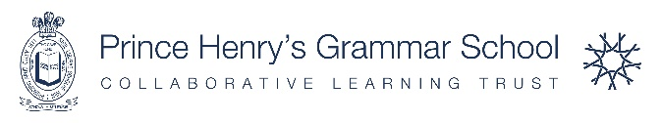

Respect. Flourish. Achieve.
We invite you and your child to make yourself aware of our acceptable use agreement. This outlines our expectations and helps ensure that we are all working together to achieve success.
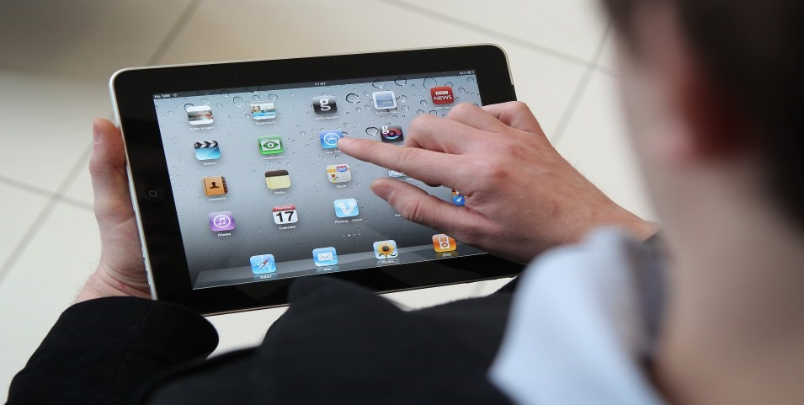
The use of iPads to assist with learning will give students the opportunity to be more creative and learn at their own pace. In some instances, they will allow home learning to be more structured and effective.

We believe that e-learning will give every student the opportunity to progress faster and achieve more.

Acceptable Use Agreement
To help ensure that e-learning is a success at Prince Henry’s we invite you to commit to the principles outlined in this agreement.
As a school we are prepared to provide all of the back-up and resources necessary to make this work, but we also require the commitment of parents and students.
As you read through this leaflet you will see a summary of the commitment that the school is making to students and to you as parents. It also outlines the commitment that will be required from home, and from the students themselves, to make this work.

The school will….
- Provide an iPad for the use of your child for the length of the programme
- Make sure that the iPad is working and that repairs are dealt with as quickly and effectively as possible
- Ensure that the iPad is protected against mobile iPad viruses
- Provide advice about caring for and protecting the iPad
As a student I will….

- Look after my iPad very carefully all of the time

- Bring it to school every day, charged and ready for a day’s work

- Take care when the iPad is transported that it is as secure as possible (e.g. not visible when walking along the street or not left unattended on a bus)

- Make sure the iPad is not subject to careless or malicious damage (e.g. as a result of silly behaviour

At home we will….
- Ensure that our child understands how to care for and protect their iPad

- Report any loss or damage (including accidental loss or damage) promptly

- Report any faults in hardware or software promptly

- Ensure that the iPad is returned either at the appropriate time or if the student leaves the school

- Make sure the iPad is not used for any illegal or inappropriate purpose, including access to inappropriate Internet sites and Chat Rooms

- Make sure the iPad is not used for any antisocial purpose such as cyberbullying

- Ensure that our child does not load any material, programmes or apps which the school might deem inappropriate and appreciate that if this happens such programmes will be removed

